Newborn Physical Exam

[A Comprehensive Newborn Examination: Part I. General, Head and Neck, Cardiopulmonary | AAFP](https://www.aafp.org/pubs/afp/issues/2014/0901/p289.html)

[A Comprehensive Newborn Examination: Part II. Skin, Trunk, Extremities, Neurologic | AAFP](https://www.aafp.org/pubs/afp/issues/2014/0901/p297.html)

[Neonatal Evaluation - StatPearls - NCBI Bookshelf](https://www.ncbi.nlm.nih.gov/books/NBK558943/)

[Mastering Newborn Exams | Stanford Medicine 25 | Stanford Medicine](https://stanfordmedicine25.stanford.edu/the25/newborn-exams-.html)

[Newborn Exam by N. Gold | OPENPediatrics](https://www.youtube.com/watch?v=cracmPo3iYo)

[neuro_evaluation-of-sacral-dimples-coccygeal-pits-2_24_2022.pdf](https://www.hopkinsmedicine.org/-/media/files/allchildrens/clinical-pathways/neuro_evaluation-of-sacral-dimples-coccygeal-pits-2_24_2022.pdf?openpdf=1)

[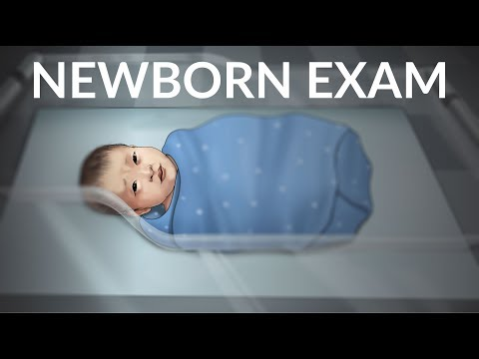](https://www.youtube.com/watch?v=cracmPo3iYo)